# How to create EC2 instance in amazon web server.

1. Go to amazon webserver login page and create a credential with your debit card and username and Password.as Root user

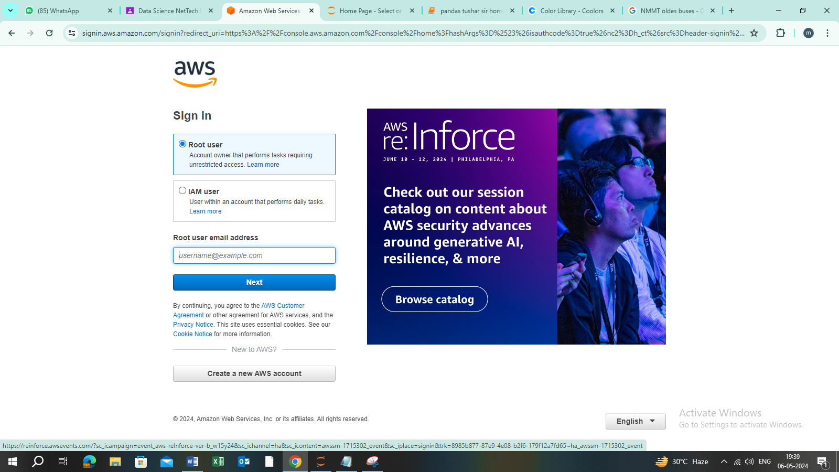

1. Go to search and mention EC2 for creating EC2 instance.
2. Create EC2 instance as followed
3. Click on launch on instance.
4. Name and tag (Best)

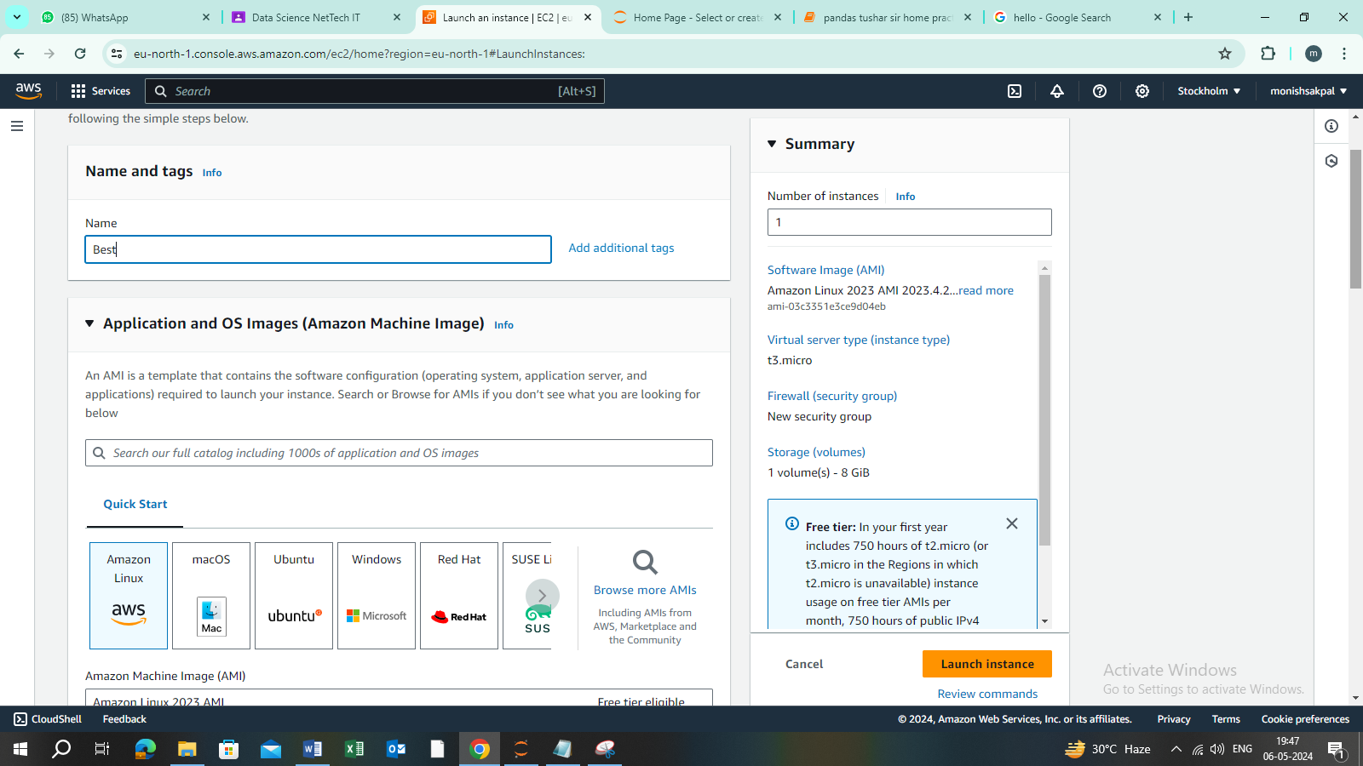

1. Application and OS Image (architecture 64 bit select free tier)

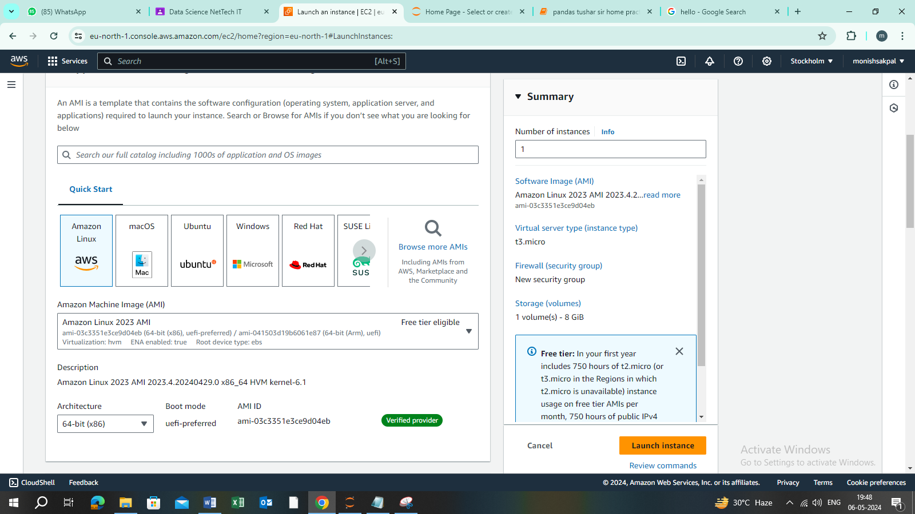

1. Instance type t3 micro.

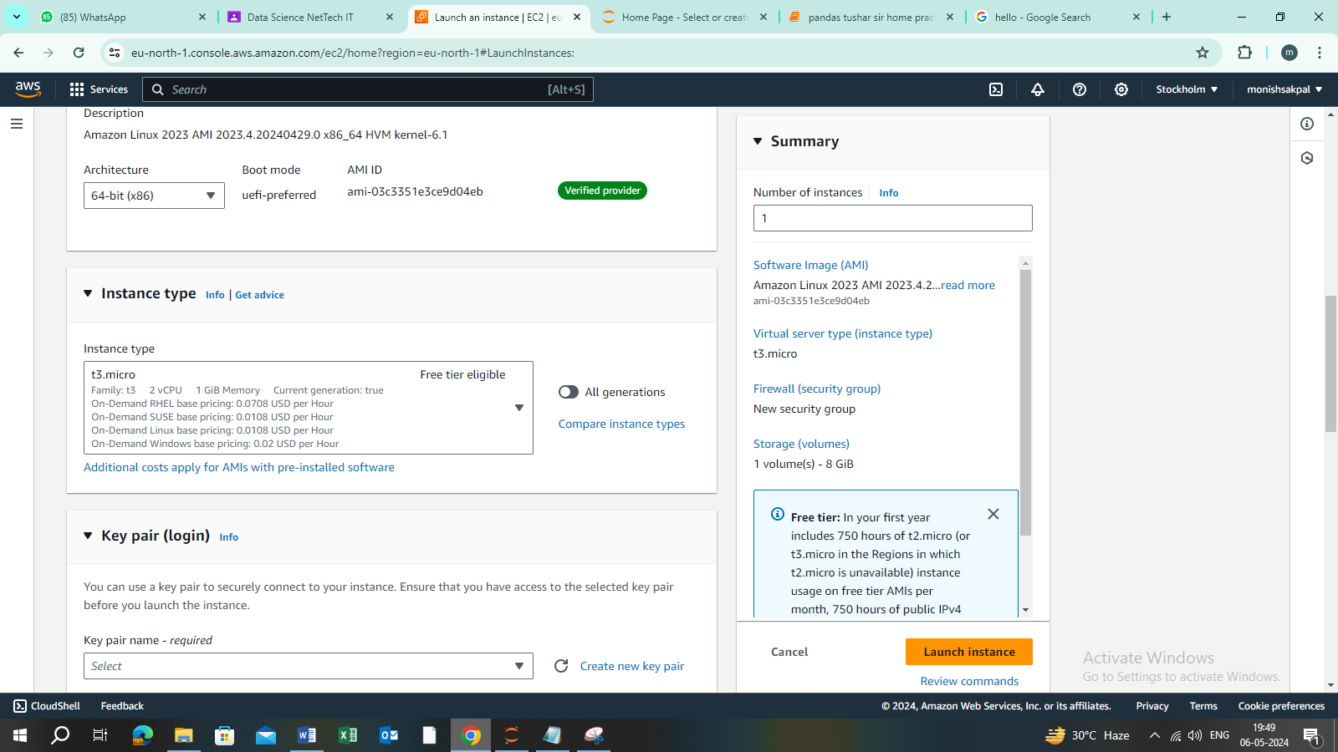

1. Create new pair key

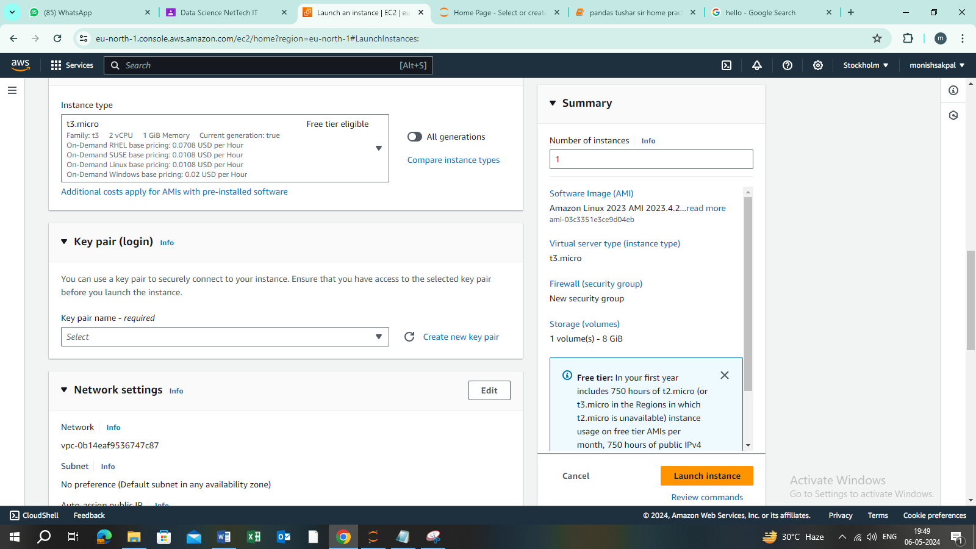

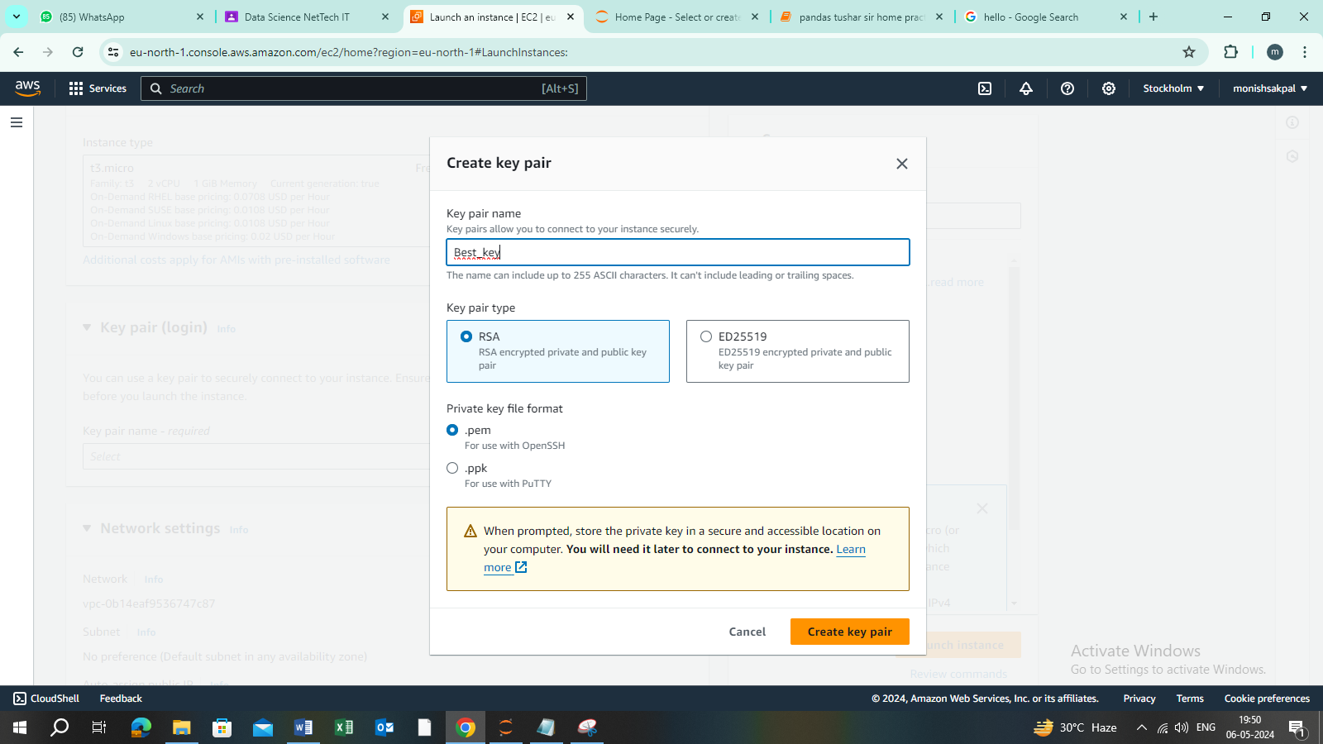

1. Create a pair.
2. Network settings.

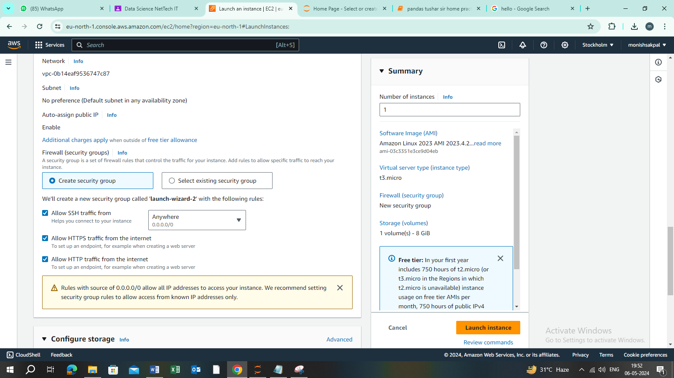

1. Launch instance.

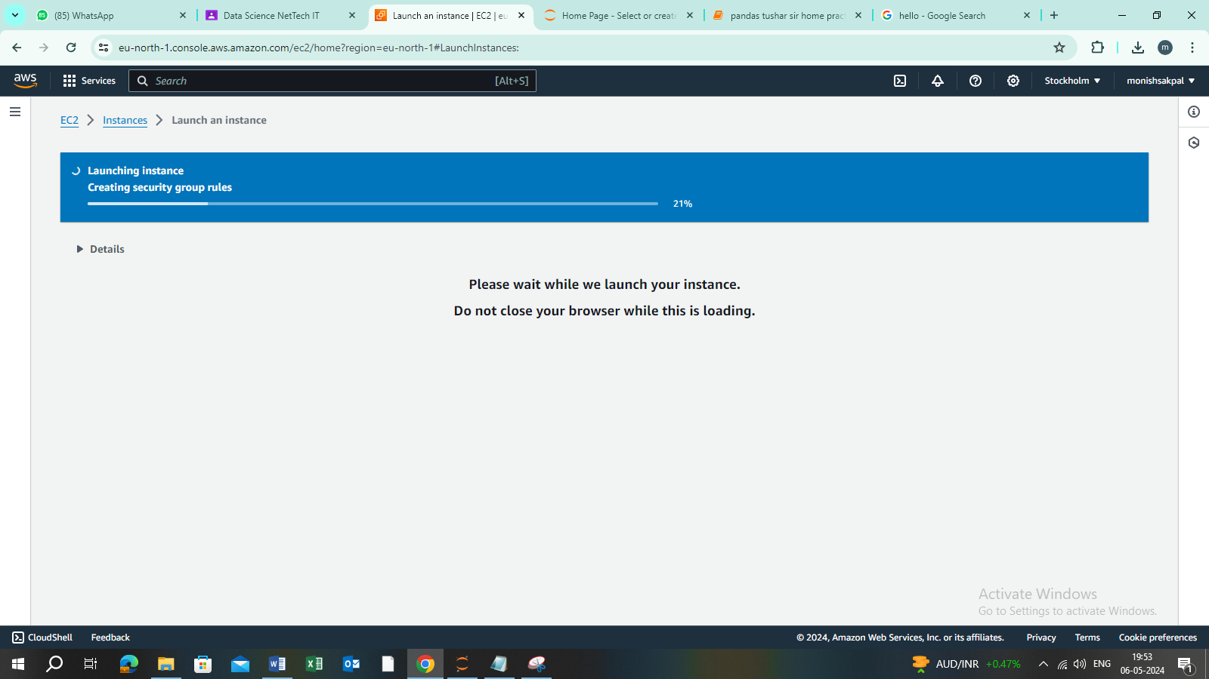

1. Instance has been created and click on connect option for connect the instance

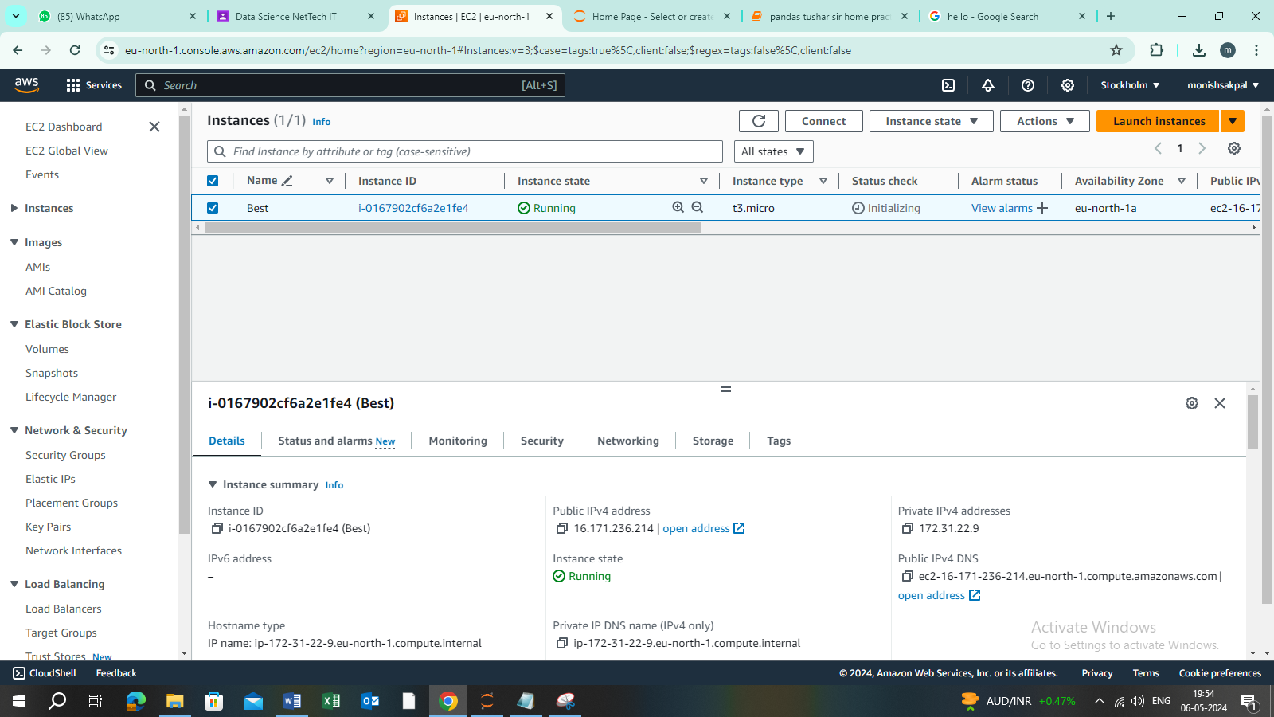

1. how to delete or terminate instance .click on instance status and terminate instance .